1.Write a JavaScript function to get the values of First and Last name from html form

2. Write a JavaScript function that accept row, column, (to identify a particular cell) and a string to update the content of that cell.

3.Write a JavaScript program to remove items from a dropdown list

4.Write a JavaScript program to count and display the items of a dropdown list,in an alert window

using regular expressions perform below validations

1. search for an item in the list and validate if it exists.
2. Update an item from the list and validate if item get updated or not.

5.Write a JavaScript program to test the first character of a string is uppercase or not.

6. Using React Applications methods create web application for user login with below validations

password shall consists of 1 upper case,1 special character, no sequence numbers shall be entered and password shall be minimum 8 chars.

8.Creating a simple counter using React which decrements count dynamically on-screen as the user clicks on the button using JSX code.

9.Implement multi page navigation using React Router between Home,Contact ,Services pages.

10.Using React Redux implement number increment and decrement state functionality.

11.implement search filter compoenent to display filtered list of strings based on search query entered by user.

Before searching:

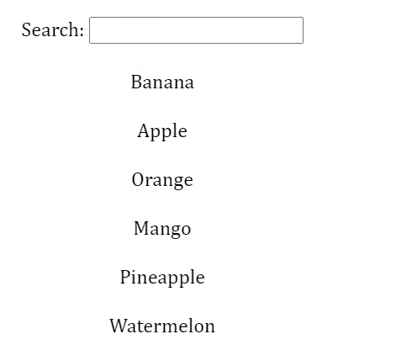

After search filter

